

*PROJECT REPORT*

*ON*

*ATTENDANCE MANAGEMENT SYSTEM*

*Submitted by:*

*Shahid Shabir Dar Submitted to:*

*& Dr.Sandeep Saxena*

*Vivek Kumar Singh*

*1.SYNOPSIS*

*Attendance management system is a software developed for student attendance in schools, collage and institutes It facilitates to access the attendance information of a particular student in a particular subject. The information is stored in database, which will be provided by the teacher for a particular subject.*

***2.****LANGUAGE AND MODULES USED*

*Python (“tkinter” module for front end)*

*“Mysqlite” browser for database*

*3.DATA TABLES*

*A.ADMIN TABLE*

|  |  |  |  |
| --- | --- | --- | --- |
| *S.NO* | ***FIELD NAME*** | ***DATA TYPE*** | ***DESCRIPTION*** |
| ***1*** | ***USERNAME*** | ***TEXT*** | ***STORES USERNAME FOR CHECKING CORRECT USERNAME*** |
| ***2*** | ***PASSWORD*** | ***TEXT*** | ***STORES PASSWORD CORRESPONDING TO USERNAME*** |
| ***3*** | ***USERTYPE*** | ***TEXT*** | ***USERTYPE ADMIN OR TEACHER OR STUDENT*** |

*B.ATTENDANCE TABLE*

|  |  |  |  |
| --- | --- | --- | --- |
| *S.NO* | ***FIELD NAME*** | ***DATA TYPE*** | ***DESCRIPTION*** |
| ***1*** | ***STUDENT_ID*** | ***TEXT*** | ***UNIQUE ID OR ROLL NO OF STUDENT*** |
| ***2*** | ***CLASSES_ATTENDED*** | ***INTEGER*** | ***CLASSES ATTENDED BY A STUDENT (MAX WORKING DAYS IN A MONTH ARE 25)*** |
| ***3*** | ***SEMESTER*** | ***INTEGER*** | ***SEMESTER OF STUDENT*** |
| ***4*** | ***SUB-CODE*** | ***TEXT*** | ***ATTENDANCE FOR THE SUBJECT*** |
| ***5*** | ***MONTH*** | ***INTEGER*** | ***MONTH OF ATTENDANCE*** |
| ***6*** | ***YEAR*** | ***INTEGER*** | ***YEAR OF ATTENDANCE OR ACDEMIC YEAR*** |

*C.STUDENT TABLE*

|  |  |  |  |
| --- | --- | --- | --- |
| *S.NO* | ***FIELD NAME*** | ***DATA TYPE*** | ***DESCRIPTION*** |
| 1 | ***STUDENT_ID*** | ***TEXT*** | ***UNIQUE ID OR ROLL NO OF STUDENT*** |
| 2 | *STUDEN­T­_NAME* | *TEXT* | *NAME OF THE STUDENT* |
| 3 | *COURSE* | *TEXT* | *COURSE OF THE STUDENT* |
| *4* | *SEMESTER* | *INTEGER* | *SEMESTER OF THE STUDENT* |

|  |  |  |  |
| --- | --- | --- | --- |
| *S.NO* | ***FIELD NAME*** | ***DATA TYPE*** | ***DESCRIPTION*** |
| *1* | *SUB_CODE* | *TEXT* | *SUBJECT CODE A UNIQE KEY* |
| *2* | *SUB_NAME* | *TEXT* | *SUB_NAME* |
| *3* | *TEACHER_ID* | *TEXT* | *SUBJECT TEACHED BY THE TEACHER* |

*D.SUBJECT TABLE*

*E.TEACHER TABLE*

|  |  |  |  |
| --- | --- | --- | --- |
| *S.NO* | ***FIELD NAME*** | ***DATA TYPE*** | ***DESCRIPTION*** |
| 1 | TEACHER_ID | TEXT | UNIQE KEY FOR TEACHERS |
| 2 | TEACHER_NAME | TEXT | NAME OF THE TEACHER |

NORMALIZATION

*1.FIRST NORMAL FORM*

*ALL THE TABLES PRESENT IN DATABASE CONTAIN ATOMIC VALUES AND SINCE ARE IN IST NORMAL FORM*

*2.2ND NORMAL FORM*

*IN ALL THE TABLES PRESENT ABOVE IN DATABASE THE NON_PRIME ATTRIBUTES ARE FULLY FUNCTIONAL DEPENDENT ON PRIME ATTRIBUTES OR CANDIDATE KEY SO ALL THE TABLES ARE IN 2ND NF*

*3.THIRD NORMAL FORM*

*ALL THE NON PRIME ATTRIBUTES THAT ARE PRESENT IN TABLES ARE MUTUALLY INDEPENDENT OR NO TRANSITIVITY IS THERE AMOUNG NON PRIME ATTRIBUTES SO THE TABLES IN DATABASE ARE IN THIRD NORMAL FORM*

ENTITY RELATIONSHIP DIAGRAM

TEACHER

TEACHES

ATTENDANCE

BELONGES

STUDIED

STUDENT

SUBJECT

SCREENSHOTS 1.login page

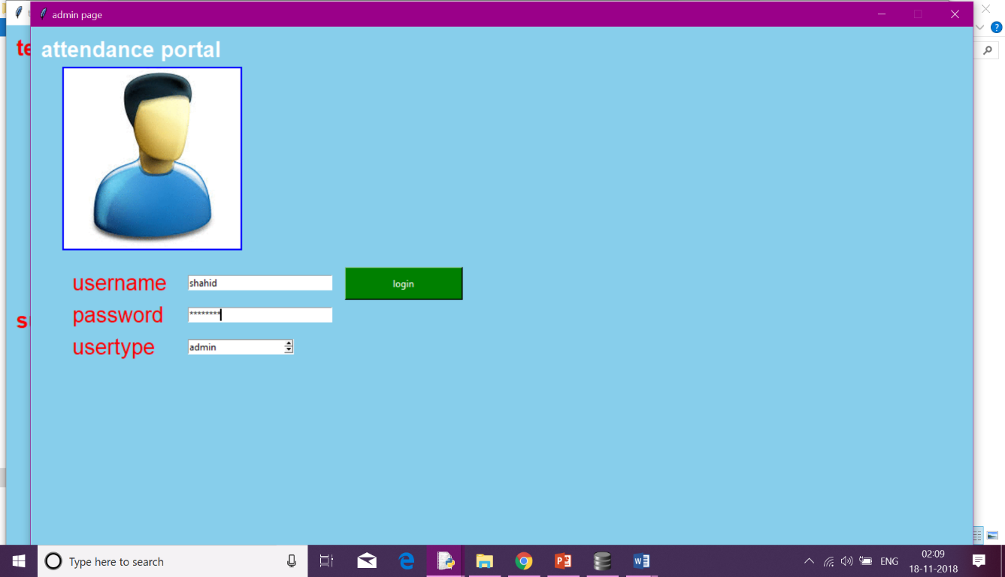

This login form is made for security purpose.So only Authenticated User can Access in to the project .There are three type of users in the project

1.admin

2.teacher

3.student

2.a.STUDENT

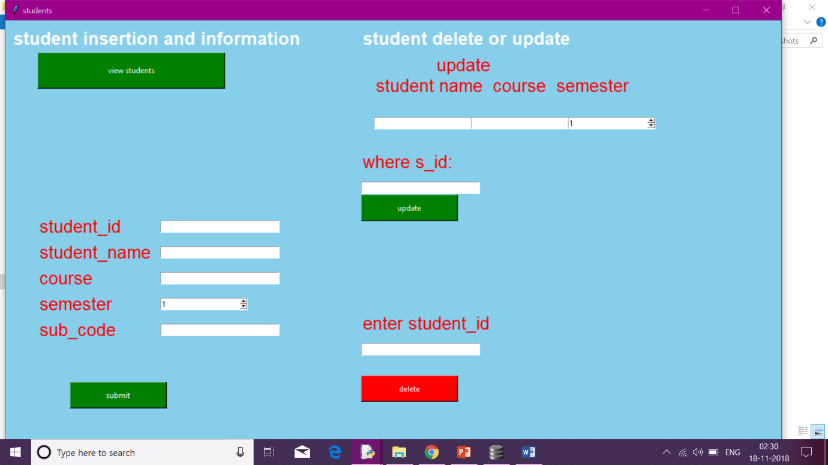

2.b. TEACHER

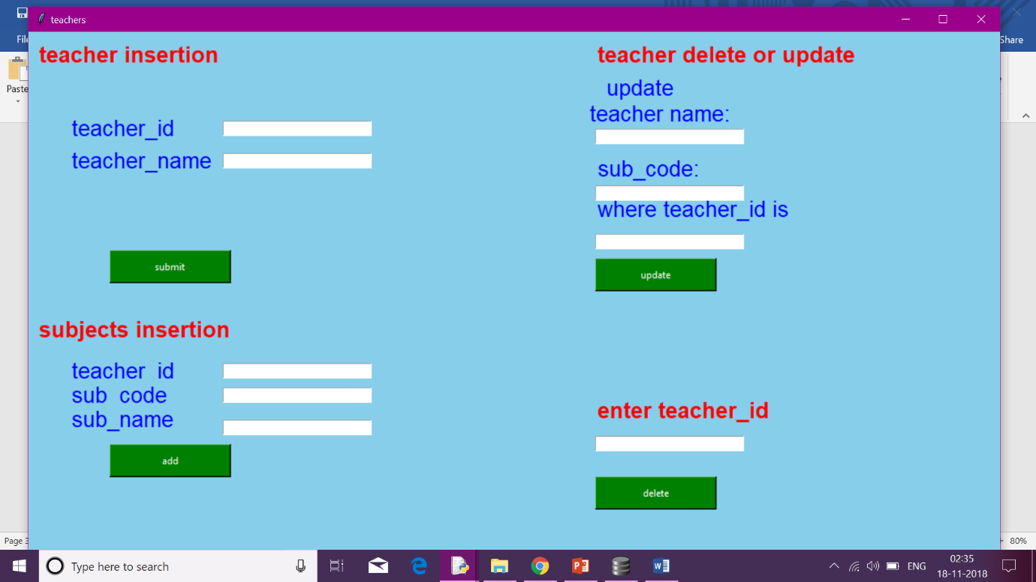

2.c. ATTENDANCE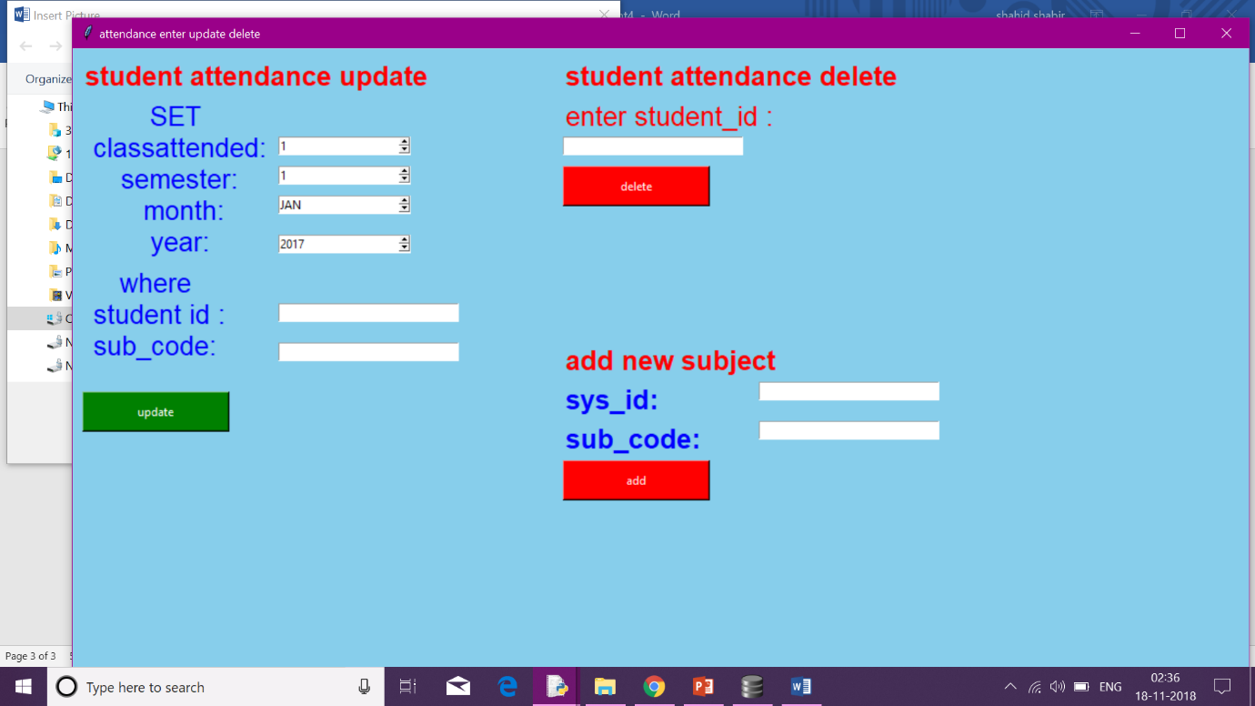

After successful authentication from login page if user is admin then he can add attendance teacher and students, if user is teacher then he can update attendance and can get the teacher view only and cannot add teacher

If user is student then he will get only his attendance information

Teacher view and student view after login are given in below screenshots

1.student view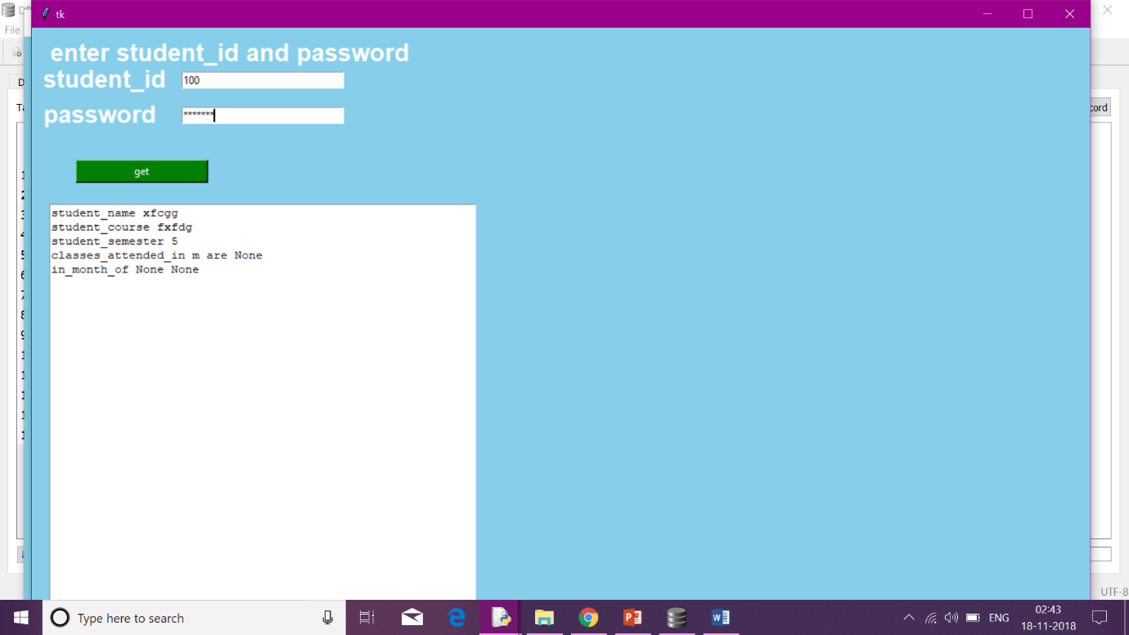

Student gets his information after giving correct username and password

2.teacher view

